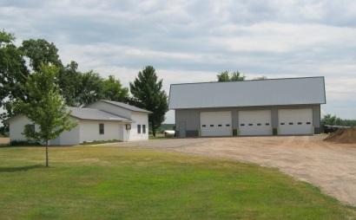

Town of CLAYTON
Public Records Request Form
164 70th Avenue
Clayton, Wi. 54004
Phone: (715) 948-2564
Note: This form is offered for your convenience to place your request for open records from the Town of Clayton. You are not required to complete this form or to provide the requested information. Personal information collected will be used for administrative purposes and may be provided to requesters to the extent required by Wisconsin’s Open Records law (ss. 19.31 – 19.39, Wis. Stats.)
The Town of Clayton will attempt to meet your request as soon as possible within time and availability constraints. If the record(s) is not readily available you will be notified within ten (10) working days as to when the record(s) will be available. There may be a charge for the record(s) you are requesting.
To Be Completed By Requester
Your Name: |  |  |  |  |  |  | Phone:
Mailing Address:
Record(s) you are requesting: (please be specific, include titles & dates):
How do you want the record(s) made available? |  |  |  |  |  |  | Review at Town Hall:
 |  |  |  |  |  |  | Copy Provided:
Send email requests to |  |  |  |  | townofclayton@amerytel.net |  | (limited availability):
Charges/Processing Fees:
Letter Size Copies (8 ½ X 11): |  |  |  |  |  | $.25/page | Certified Survey Maps: |  |  |  | $3.00/Copy
Colored Copies (8 ½ X 11): |  |  |  |  |  | $.30/page | Mailing/Shipping: |  |  |  | Actual Costs
Location of Records: Costs associated with locating records will be charged if they total $50 or more.

All record requests will also be charged for the Clerk’s time at an hourly rate of $15.00 with an hour minimum charged.
~All costs must be paid prior to release of records.
~If costs are anticipated to exceed $5.00 prepayment will be required before copies will be produced.
For Internal Use Only
Date Request Received: |  |  |  |  |  |  | Received By:
Amount Due:
Date Paid:
Receipt #:
Received By:
Request Fulfilled By:

